* **@ManyToMany**
  + **Basic**

VD1:

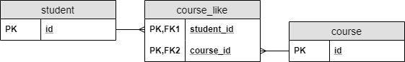

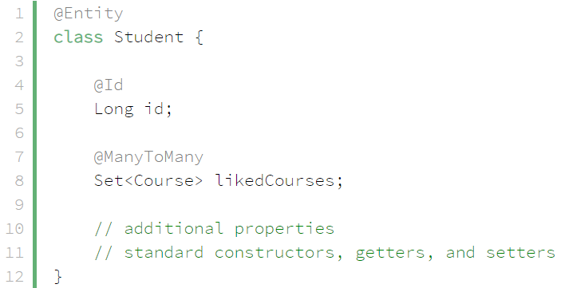 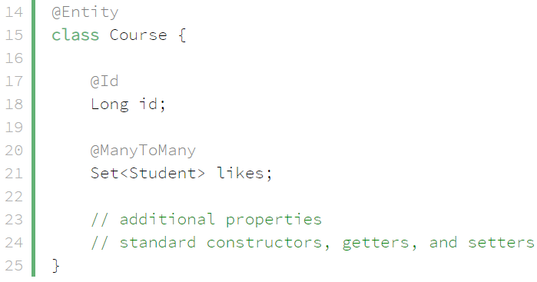

VD2:

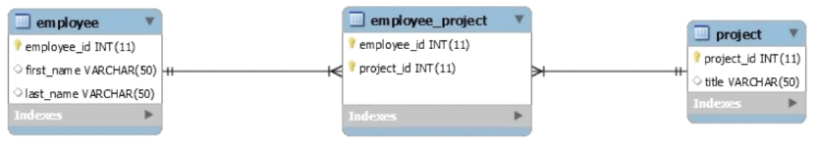

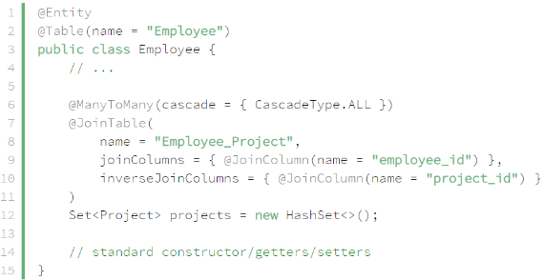 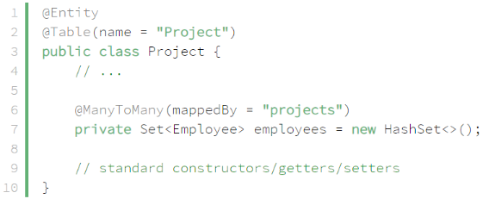

*mappedBy projects which is variable in Java*

* + **Using a Composite Key**

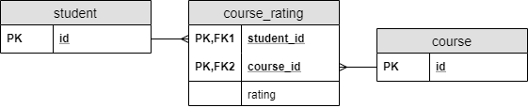

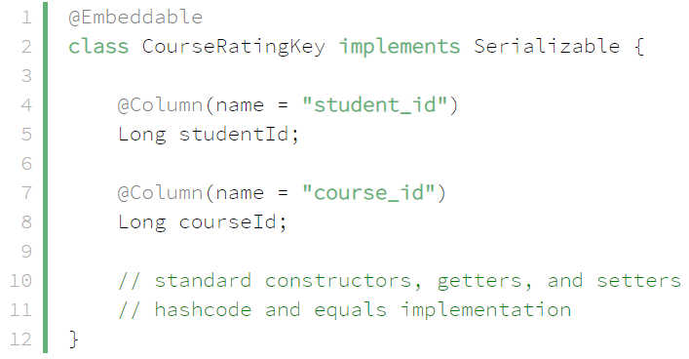

*Creating a Composite Key*

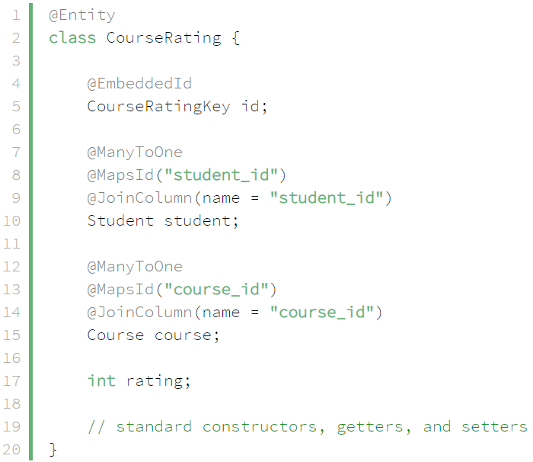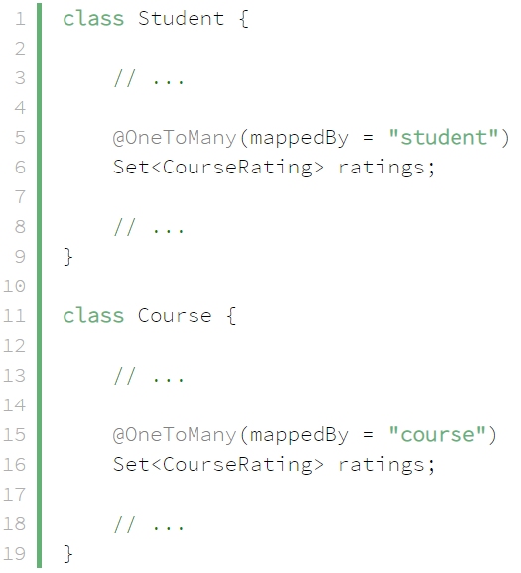

* + **New Entity**

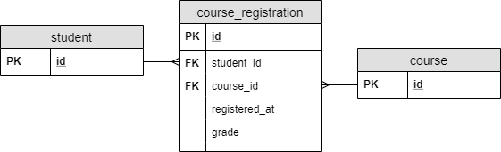

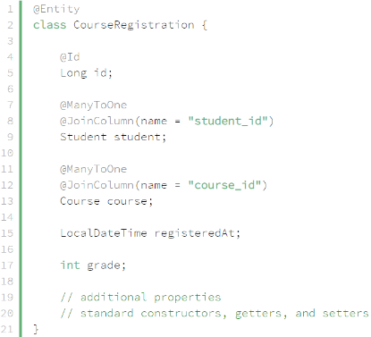 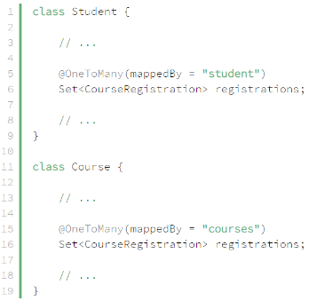

* **Reference**

<https://www.baeldung.com/hibernate-many-to-many>

<https://www.baeldung.com/jpa-many-to-many>